**Learners have to develop a Report to support the answers to the following questions and suggestions.**

**Objective Questions:**

1. What is the total number of attributes in the customer table?

Ans. The customers table has 3 attributes: CustomerID, CustomerAge, CustomerGender.

1. How will you get the “Customer’s” ages in the “Order” tables according to customer IDs?

Ans. Steps are as follows:

* Load both Orders and Customers tables
* Open Power Query Editor
* Merge Queries on CustomerID
* Expand Customer Age field
* Rename Column if needed
* Close & Apply

1. In analyzing the dataset with Power BI, ensure data cleaning to address inconsistencies and missing values before further analysis.

Ans. In Power BI, I used Power Query Editor to:

* Removing duplicates.
* Handling blank rows by removing it.
* Ensuring data types are correct.
* Removing extra blank columns.

1. How can we calculate the total revenue generated by all the sales?

Ans. Create a New Measure:

* Go to the Orders table → Right-click → New Measure.
* TotalRevenue = SUMX(Orders, Orders[Sale Price] + Orders[Shipping Fee])

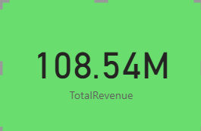

1. What is the total number of unique customers who made purchases each year? Is there any increase in the number over the years?

Ans. UniqueCustomers = DISTINCTCOUNT(Orders[CustomerID])

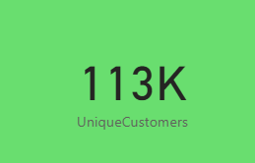

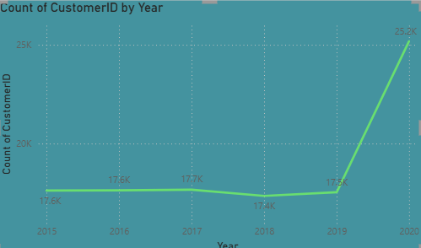

Insights:

•Here, the unique customer count shows a steady increase from 2019 to 2020, this indicate that successful marketing strategies or an expanding product range that attracts new customers.

•A year with a slight drop from year 2017 to 2018 can be into potential issues like product availability, pricing changes, or increased competition.

1. How can we determine the total number of unique products available in the company?

Ans. Create A new Measure:

UniqueProducts = DISTINCTCOUNT(Orders[Product])

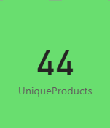

1. What is the average number of days it takes for products to be delivered, get the metric for only the delivered orders.

Ans. First Create a Measure using dax function:

Average Delivery Days = AVERAGEX(FILTER(Orders,Orders[Status]="Delivered"), DATEDIFF(Orders[OrderDate],Orders[Delivery Date],DAY))

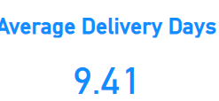

1. Which products, categories, and subcategories are the most popular?

Ans. 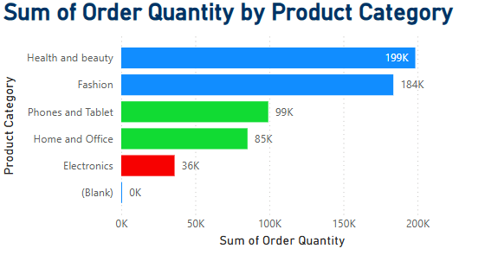

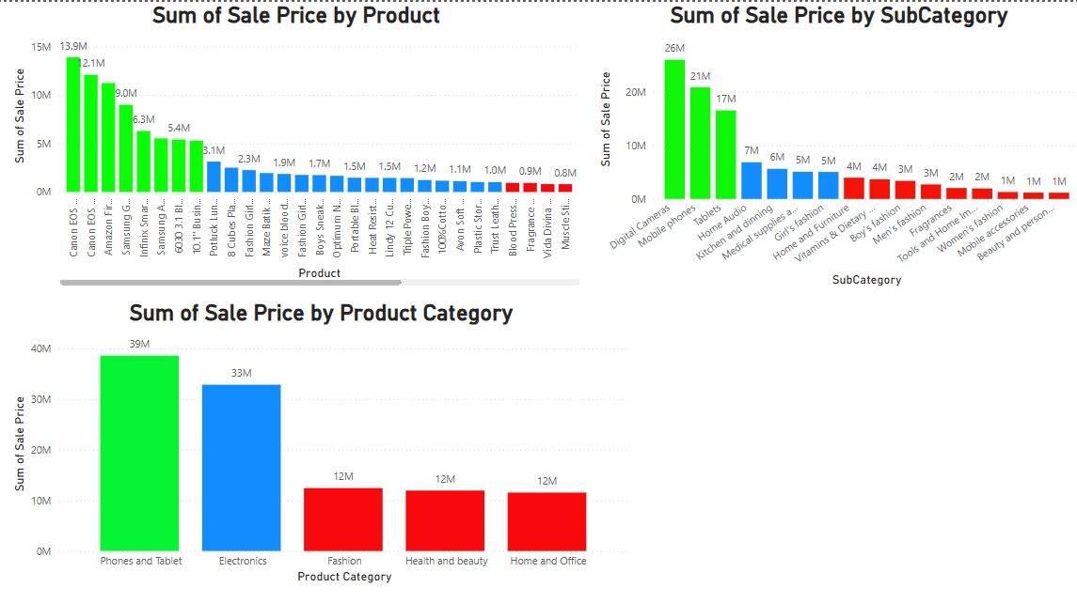

1. Which products have seen an increase or decrease in sales over the year?

Ans. 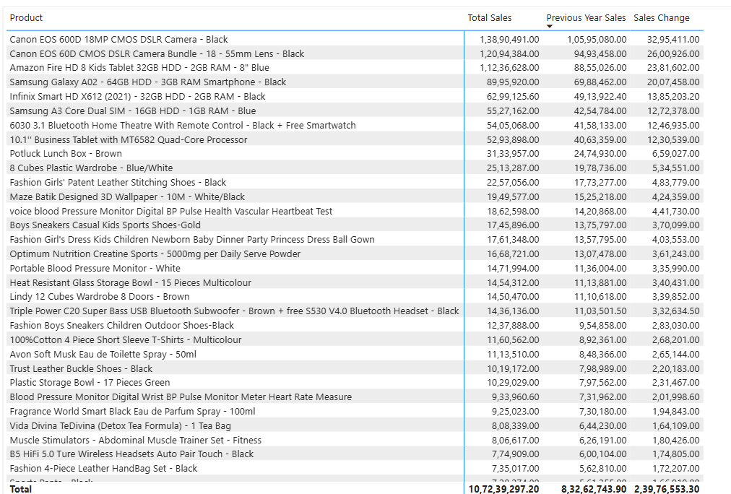

1. While modeling the data relationships, what will be the type of relationship between the customer ID of Orders and customer tables?

Ans. One to one 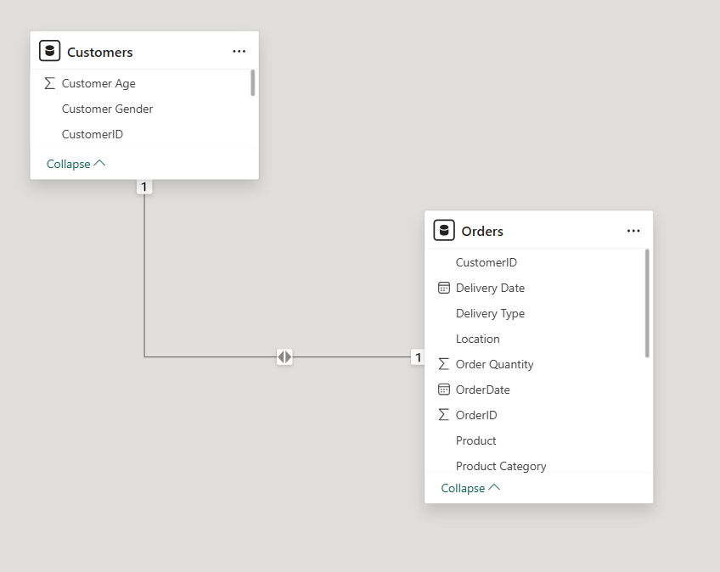

1. How have you handled the null values in the data?

Ans. • Use of Power Query Editor to filter out or remove null values.

• Use of Power Query Editor, if any blank rows are present which helps to remove the bottom/top rows.

• If any blank values in our data, then we create a measure:

Sale Price Cleaned = IF(ISBLANK(orders[Sale Price]), 0, orders[Sale Price])

By using above measure, our data will not be modified or no changes in our values will be affected.

1. Were there any data format issues in the data, and if there were/are how you would handle them?

Ans. • In our data, there was no need to change the data types.

* If there was such an issue to format the datatypes then I can check and transform data types in the Power Query editor.
* Where the use of Power Query editor is to change data types where necessary (e.g., dates are recognized as date types, numerical values as numbers, text in string format).

1. When we add a column in Power Query what’s the code that comes in M language in the formula bar? What do you know about M-query?

Ans. When we add a column in Power Query, the code that comes in M language in the formula bar is as follows:

Syntax:

= Table.AddColumn(PreviousStep, "NewColumn", each [Column1] + [Column2])

Example:

= = Table.AddColumn(#"Removed Columns", "Custom", each null)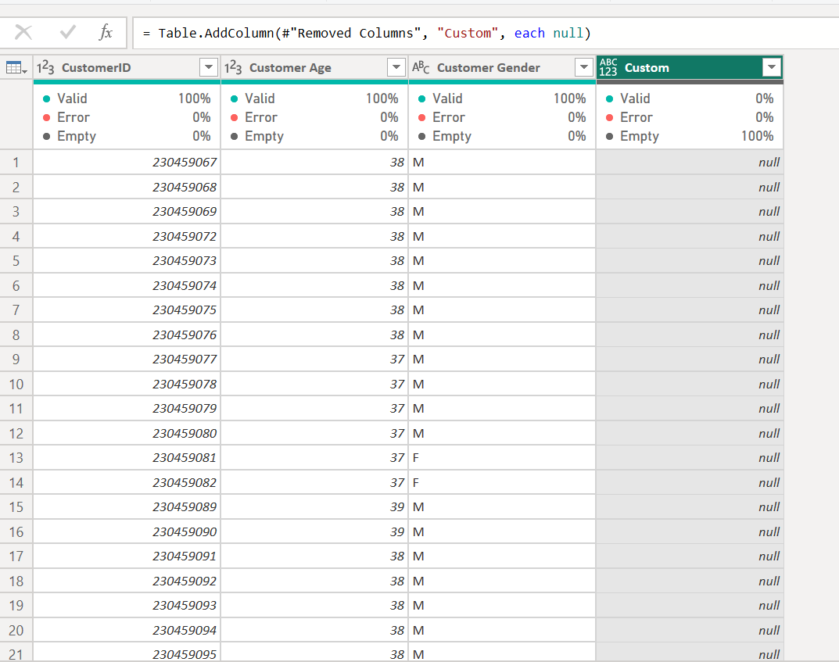

1. Identify the top 5 most valuable customers using a composite score that combines three key metrics: (SQL)
   1. Total Revenue (50% weight): The total amount of money spent by the customer.
   2. Order Frequency (30% weight): The number of orders placed by the customer, indicating their loyalty and engagement.
   3. Average Order Value (20% weight): The average value of each order placed by the customer, reflecting the typical transaction size.

Ans. 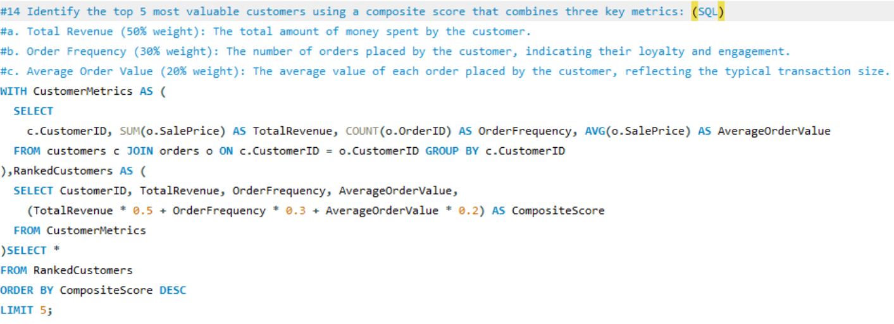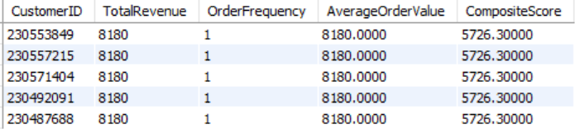

1. Calculate the month-over-month growth rate in total revenue across the entire dataset. (SQL)

Ans. 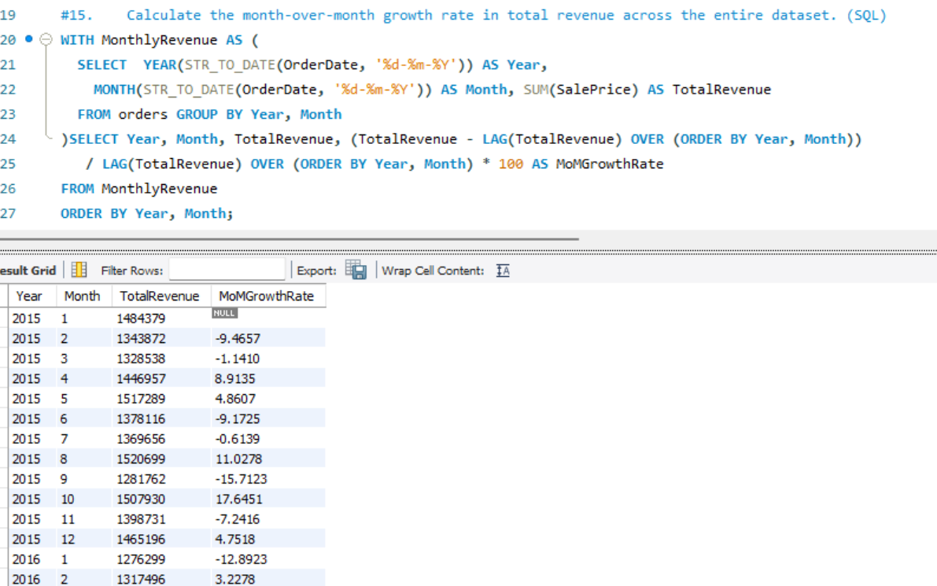

1. Calculate the rolling 3-month average revenue for each product category. (SQL)

Ans. 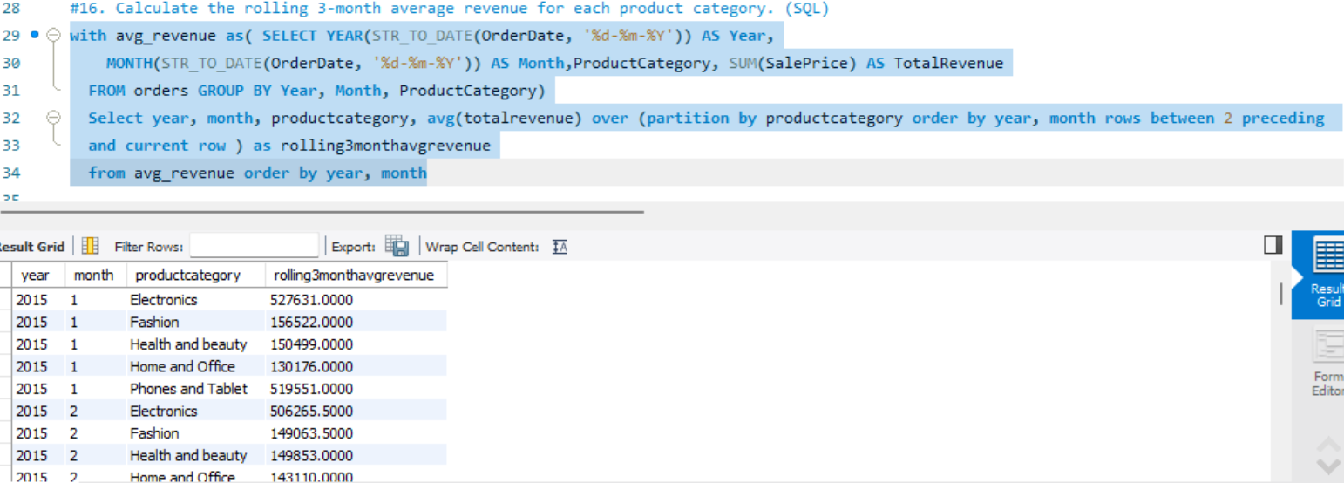

1. Update the orders table to apply a 15% discount on the `Sale Price` for orders placed by customers who have made at least 10 orders. (SQL)

Ans. 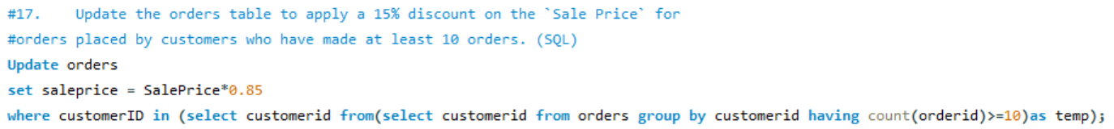

1. Calculate the average number of days between consecutive orders for customers who have placed at least five orders. (SQL)

Ans. 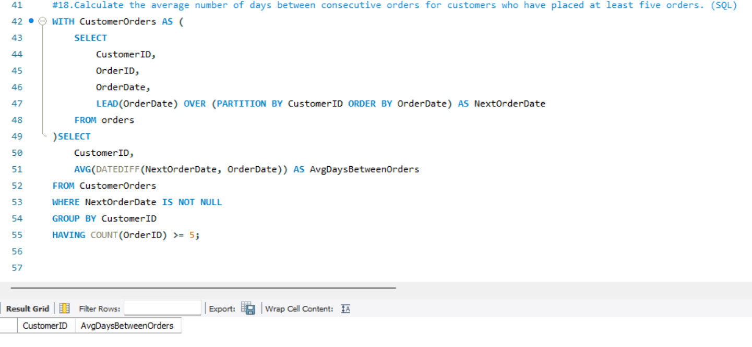

1. Identify customers who have generated revenue that is more than 30% higher than the average revenue per customer. (SQL)

Ans. 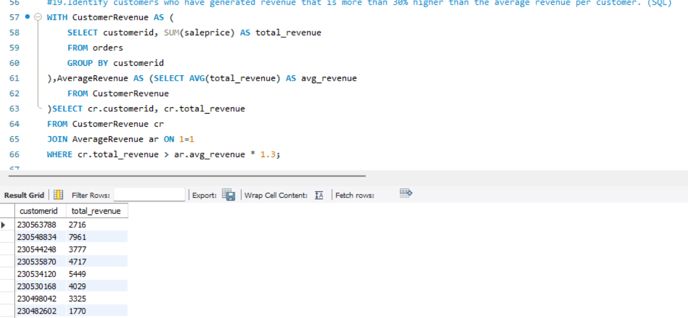

1. Determine the top 3 product categories that have shown the highest increase in sales over the past year compared to the previous year. (SQL)

Ans. 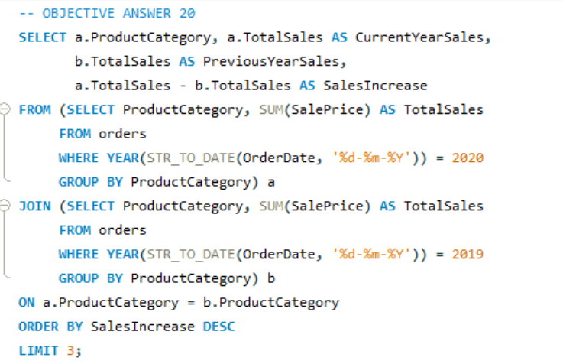

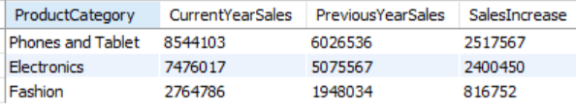

**Subjective Question:**

1. Explain the revenue breakdown by year and by-product. Evaluate how different products contribute to annual revenue and come up with suggestions to increase the sales of the low-selling items.

Ans. 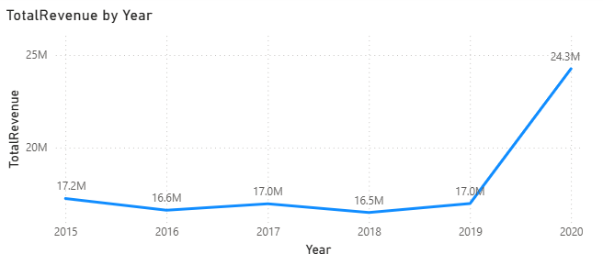

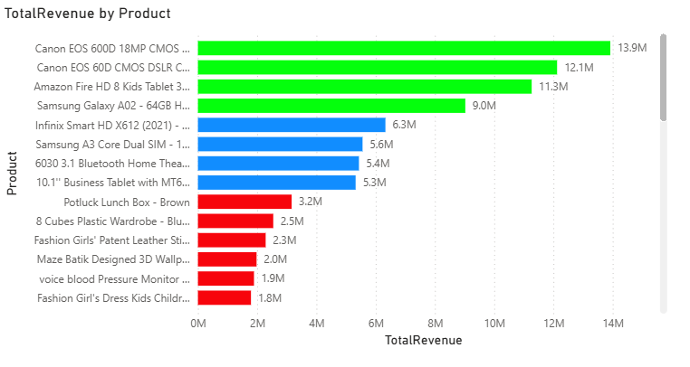

**Suggestions:**

* **Run Targeted Promotions:** Offer discounts, bundles with popular items, or limited-time offers specifically on the low-selling products to create a sense of urgency and incentivize trial.
* **Highlight Value Through Content:** Create blog posts, social media content, or videos showcasing the unique benefits and potential uses of these items to educate potential customers.
* **Bundle with High-Performing Products:** Strategically group low-selling items with popular ones at a discounted price to increase their visibility and perceived value.
* **Gather and Act on Customer Feedback:** Actively solicit feedback on the low-selling products to understand why they aren't performing well and implement necessary improvements or adjustments.
* **Improve Online Visibility and Placement:** Ensure these items have prominent placement on company’ website or online store, with clear and compelling product descriptions and high-quality images.

1. How many products were returned? Use a DAX function to get this metric. Examine the possible reasons for returns and consider how this metric could indicate improvements in product descriptions or quality control.

Ans. 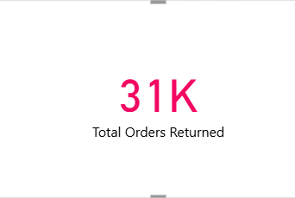

**1. Reason for Returns: Inaccurate Descriptions**

* **Explanation:** Product received doesn't match the advertisement (size, color, features, etc.).
* **Suggested Improvements:**
  + **Detailed Product Descriptions & Visuals:** Provide comprehensive, accurate text, images, and videos.
  + **3D/AR Visualization:** Offer interactive ways for customers to see the product.

**2. Reason for Returns: Product Quality Issues**

* **Explanation:** Defects, damage, or doesn't meet quality standards.
* **Suggested Improvements:**
  + **Stronger Quality Control:** Implement thorough checks during manufacturing and packaging.
  + **Better Packaging & Handling:** Use protective materials and train staff for careful handling.

1. Whenever a customer goes to Amazon, they’ll filter the most rated products to buy the better category. Can you verify this using any visualization or table that the ratings of products impact their sales value?

Ans.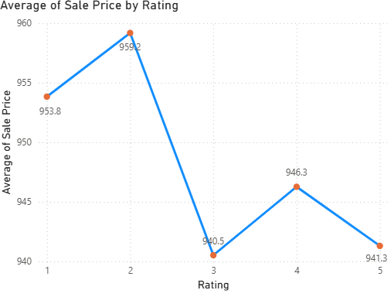

**INSIGHTS:**

1. **High Ratings Drive Sales:** Customers often prioritize highly-rated products when filtering, leading to a noticeable increase in sales for items rated above 4 stars. This confirms that ratings are a significant factor in purchasing decisions.
2. **Leverage High Ratings in Marketing:** Concentrating marketing efforts on products with strong ratings can be an effective strategy to further boost their sales potential by capitalizing on existing positive social proof.
3. **Improve Low-Rated Products:** Products with lower ratings warrant careful analysis. Customer reviews can provide valuable feedback on areas needing improvement. Addressing these issues can lead to higher ratings and, consequently, increased sales.
4. Investigate how revenue distribution varies across different locations. Explore which geographical areas contribute most to sales and consider the strategic implications for regional marketing and distribution efforts. How might location-based trends inform the company's market segmentation and resource allocation approach?

Ans. 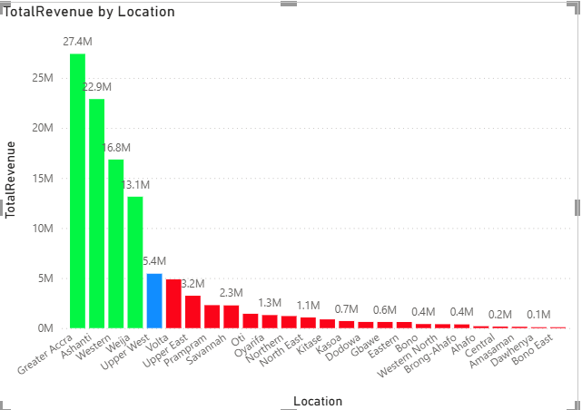

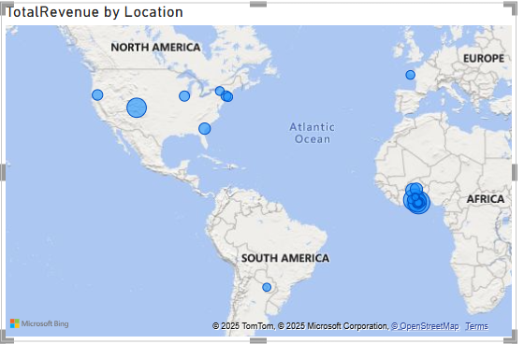

**Insights:**

* **Greater Accra** brings in the most money, with 27 million. This makes it a very important area for the business.
* Other regions like **Upper West** and **Eastern** also bring in a good amount of money, showing that the business is doing well in several areas.
* **Oti** region has low sales. This could mean there's room to improve, possibly with better marketing or more attention.

**How location-based trends can help a business:**

* Looking at sales by location shows which areas are making the most money.
* People in different places may buy differently. This means the company can make changes to products or services to better fit local needs.
* Knowing which areas are doing well can help the company plan better—like sending more products to high-selling regions and saving costs in low-selling ones.

1. Determine which month could benefit from enhanced promotional offers to boost sales. Can you suggest some targeted marketing strategies here?

Ans. 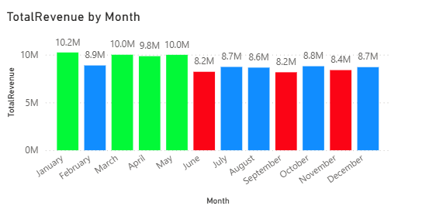

**Insights:**

* **January (10.2M)** is the top-performing month and doesn't need additional marketing support.
* **June (8.2M)** and **October (8.2M)** show the **lowest revenue** and should be prioritized for improvement.
* **July, September, and December** have **moderate sales** (between 8.6M and 8.7M) and could benefit from seasonal promotions.
* **February (8.9M)** is just below the 9M threshold—worth monitoring for light marketing boosts.
* **March, April, and May** all perform well with **revenues near or above 9.8M–10M**, indicating steady performance.

**Targeted Marketing Strategies:**

* **June and October**: Launch special campaigns like **mid-year clearance sales** and **off-season promotions** to boost low sales months.
* **July, September, and December**:
  + **July/September**: Try **back-to-school sales**, **travel bundles**, or **summer-end clearance**.
  + **December**: Leverage **holiday-themed offers**, **gift bundles**, and **loyalty points** to increase end-of-year spending.
* **February**: Consider **Valentine’s Day promotions** or limited-time offers to push it over the 9M mark.

1. Identify which products may require increased marketing efforts. Which items have high prices yet underperform in sales?

Ans. **Insight Summary:**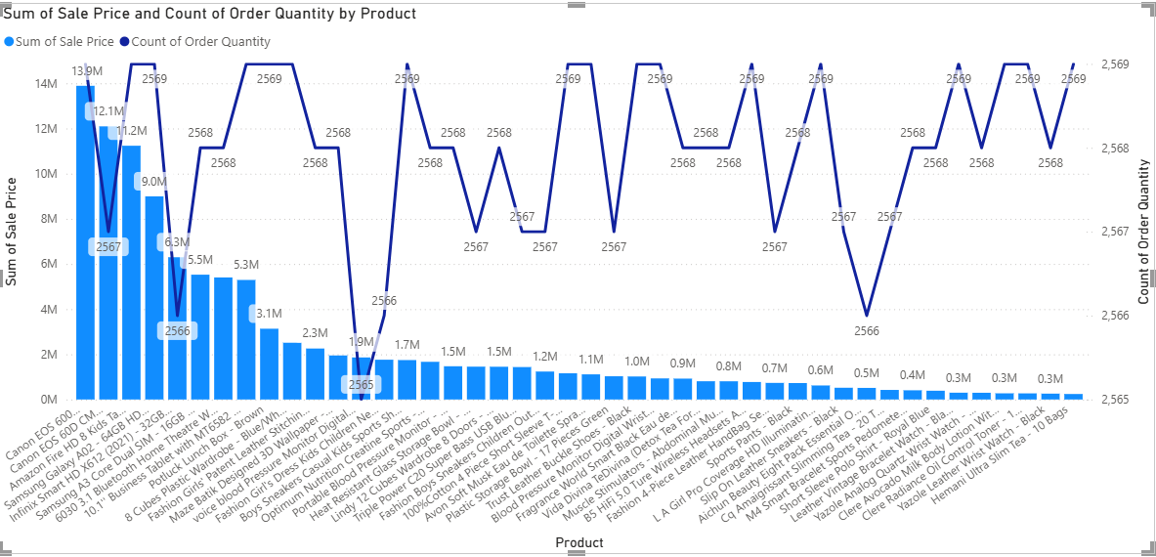

After analyzing the graph, **two products stand out** with **high sale prices** (tall bars) but **very low order quantities** (flat line):

* **Canon EOS 600D DSLR Camera**

**Infinix Smart HD X612(2021)-32GB-2GB RAM- Black.**

These items clearly have **premium pricing** (₹13.9M, ₹6.2M total sales), yet the **order quantities are at the lower end (2567 or below)**. This mismatch between high pricing and lower purchase volume indicates they are **underperforming** in terms of units sold despite generating revenue.

**Business Interpretation:**

These products:

* Belong to **high-end electronics**, where price sensitivity is usually high.
* May be **perceived as too expensive** or **lack strong brand awareness/USP visibility**.
* Could be **outshined by competing products** offering similar specs for less.

**Suggested Marketing Strategies:**

**1. Reinforce Value Proposition**

* Highlight **advanced camera features**, **sensor quality**, **video capabilities**, etc., through **educational campaigns** or influencer reviews.
* Create **side-by-side comparisons** showing why this camera is worth its price.

**2. Use Targeted Promotions**

* Offer **limited-time discounts**, **cashback deals**, or **accessory bundles** (free tripod, memory card).
* Push **festival/seasonal campaigns** to create urgency.

**3. Improve Visibility**

* Run ads on **photography communities**, YouTube gear review channels, and **retarget interested users**.
* Create **demo videos** or **AR previews** to showcase product experience.

**4. Customer Trust Tactics**

* Add **testimonials from professionals**, **warranty benefits**, and **easy return policies** to reduce hesitation.
* Launch **EMI plans** or no-cost installment options.

**5. Evaluate Pricing Strategy**

* If sales remain stagnant, consider a **competitive price revision** or launch a **“lite” version** at a lower price point.

1. Assess which products should have discounts. How can targeted incentives drive sales and customer loyalty for specific products?

Ans.

Here's a rewritten analysis and set of recommendations based on the provided graph and initial insights:

**Analysis of Sales Price and Order Quantity by Product:**

* We looked at how well each product sold. Two products have high prices but haven't sold much, like the graph shows.
* These two products cost more than similar products from other brands. But they haven't sold a lot. Maybe customers think they cost too much or don't know why they are worth the price.
* Because of this, these products might sell better if we try different ways to market them and explain why they cost more.

**Recommendations to Enhance Sales:**

To address the lower order volume of higher-priced items like the Canon EOS 60D DSLR and the Infinix Smart HD, consider implementing the following strategies:

* **Implement Strategic Discount Campaigns:** Introduce limited-time offers or exclusive discounts specifically targeted at these higher-priced, lower-volume products. This can alleviate the perceived high cost and make them more attractive to price-conscious buyers.
* **Personalized Incentive Programs:** Offer discounts or exclusive deals tailored to individual customer preferences or their past purchase behavior. This can create a stronger incentive for hesitant buyers to consider these products.
* **Highlight Value and Benefits:** Focus marketing efforts on clearly communicating the unique value proposition and benefits of these products to justify their higher price point. This could include showcasing superior features, quality, or performance.
* **Consider Bundling Strategies:** Explore creating attractive bundles that include these higher-priced items along with complementary, lower-priced accessories or services. This can increase the perceived value and make the overall package more appealing.
* **Run Targeted Visibility Campaigns:** Implement promotions specifically designed to draw attention to these products, potentially highlighting any ongoing discounts or special offers. This can increase their visibility among potential customers who might have overlooked them otherwise.

1. Come up with a loyalty program to benefit the company’s customers. From the available lot of customers come up with strategies to bucket them and provide benefits under different loyalty programs.

Ans. 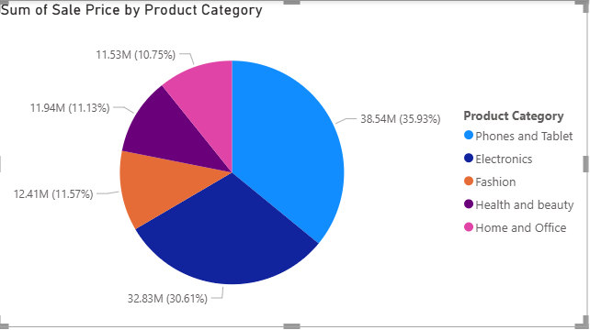

**Loyalty Program Ideas Based on Sales by Product Category:**

1. **Tiered Rewards for Top Categories:** As visualized in the pie chart, **Phones and Tablet** represents the largest portion of total sales at **35.93% (₹38.54M)**. To capitalize on this high-performing category, our loyalty program can offer tiered rewards to customers who frequently purchase within it. For example, Silver or Gold tier members who consistently buy Phones and Tablets could earn extra loyalty points per purchase, receive exclusive discounts on accessories or related services, or gain early access to new product releases in this category.
2. **Seasonal Loyalty Offers for Key Categories:** The pie chart indicates that **Electronics** is the second-highest contributor to sales at **30.61% (₹32.83M)**. We can implement seasonal loyalty offers targeted at this and other significant categories (like **Fashion** at **11.57% (₹12.41M)**) during peak buying seasons. For instance, during a "Back to School" promotion, offering bonus loyalty points or discounts on Electronics like laptops or headphones could drive sales within this substantial segment. Similarly, seasonal fashion sales could be boosted with category-specific loyalty rewards.
3. **Referral Rewards Focused on High-Value Categories:** Encourage customer referrals by offering enhanced rewards specifically tied to purchases made by referred customers within high-value categories such as **Phones and Tablet** and **Electronics**. For example, a successful referral that results in a new customer purchasing a Phone or Tablet could earn the referring customer a significantly higher number of loyalty points or a more substantial discount voucher applicable to their next purchase in any category, but with a greater incentive for top-selling ones.
4. Using the DAX functions Calculate and a row iteration DAX function calculate the total sales for the Product Category “Fashion” and delivery type “Shipped from Abroad”. What are the other types of DAX functions you have used in the project?

Ans. 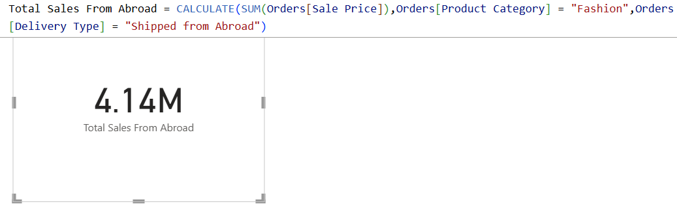

Other DAX Functions:

• **SUMX**: Iterates over a table and sums the expression for each row.

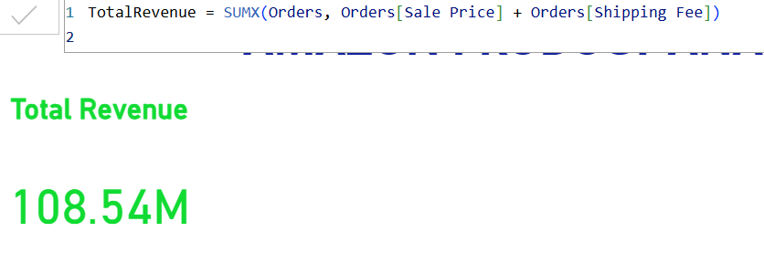

* **DISTINCTCOUNT**: Counts the number of unique, non-blank values in a specified column.

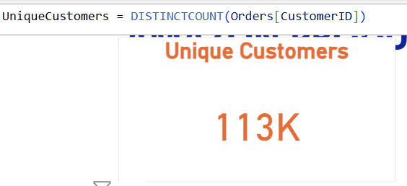

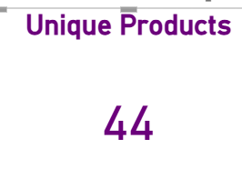

* **AVERAGEX**: Calculates the average over a table or expression.
* **FILTER**: Returns a table that represents a subset of another table based on a condition.
* **DATEDIFF**: Calculates the difference between two dates in a specified unit (e.g., days, months, or years).



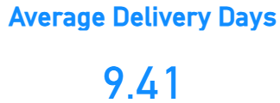

* **CALCULATE**: Modifies the context of a calculation and evaluates an expression based on filters or conditions.
* **COUNTROWS**: Returns the number of rows in a table or table expression.



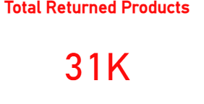

* **AVERAGE**: Calculates the average of a column.
* **ALLEXCEPT:** Removes filters from all columns in a table, except for the specified columns.

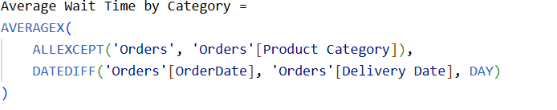

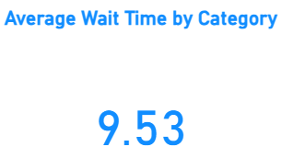

* **SAMEPERIODLASTYEAR**: Compares the current period with the same period from the previous year.

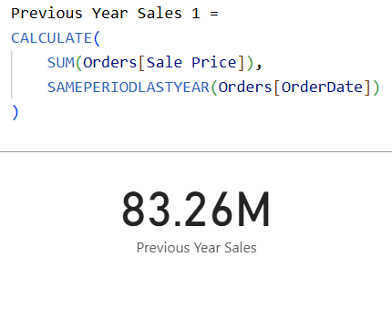

1. Wait Times Correlated with Demographics and Care: Explore how average wait times vary across different product categories to optimize scheduling and staffing.

Ans. **Answer**: Average Delivery Days is same across all Product Category i.e 9.53days.

**Approach**: First calculated the wait time by creating a new Measure : Delivery Days with datediff function. And then used Column Chart to plot the Category wise Average waittime.





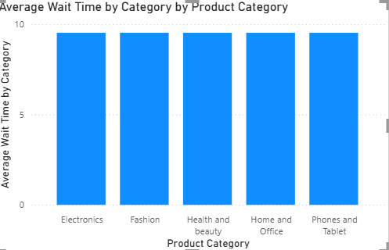

1. Explore if there is any relationship between the Delivery type and waiting time between ordering and receiving an item.

Ans. 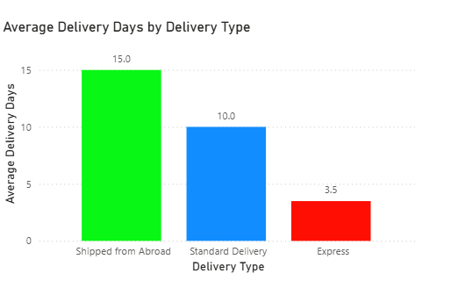

Yes, Express Delivery Type’s wait time is very less as compared to the remaining types.

**Approach**: Used Column Chart to plot the Avg Delivery Days and Delivery Type view.

**Observation**:

2 **Express Delivery**:

* **Delivery Time**: Products are delivered within **4 days**.
* **Key Insight**: This is a fast and efficient delivery option, likely to appeal to customers who prioritize speed and convenience. It ensures quick access to products, enhancing customer satisfaction and encouraging repeat purchases.

**Shipped from Abroad**:

* **Delivery Time**: Takes approximately **15 days**.
* **Key Insight**: Products shipped from abroad experience a longer wait time due to international shipping processes, customs, and other logistical factors. While this may cause some frustration, it’s common for items from international markets. The longer delivery time may impact customer expectations, making it essential to clearly communicate estimated delivery times at the point of purchase.

1. Is there any relationship between shipping charges and product type?

Ans. There is no variation in shipping charges across different product categories.  
**Approach:** A column chart was used to visualize the Shipping Fee against Product Categories, which showed uniform values for all types. 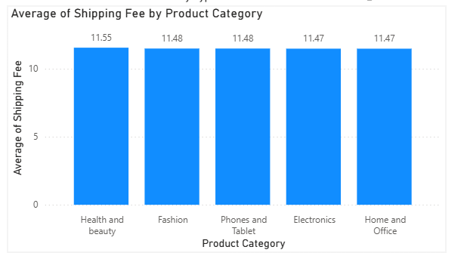

1. Come up with strategies to decrease the low rating orders after analyzing different factors like waiting time, shipping type, unit price, etc.

Ans. Below visualization shows the difference between each of the metrics for lower ratings (<3 ratings) and high rated orders (4&5 ratings).

* + **Average Delivery Days and Ratings:**
* Observation: Delivery time shows minimal difference between rating groups, remaining around 9.4 days. This suggests delivery time has a negligible effect on ratings.
* Action: Prioritize improvements in areas other than delivery speed, such as packaging quality and order accuracy, to boost customer satisfaction.
* **Order Count by Delivery Type and Ratings:**
* Observation: Order distribution across delivery types is similar for both rating groups. However, "Shipped from Abroad" has a slightly lower order volume.
* Action: Investigate potential issues with "Shipped from Abroad," like longer delivery times or higher costs. Consider promoting faster shipping options and optimizing the international shipping process.
* **Average Unit Price and Ratings:**
* Observation: Lower-rated orders have a moderately higher average unit price (approximately 298.91) compared to higher-rated orders (approximately 292.44).
* Action: Re-evaluate pricing for higher-priced items. Explore discounts or bundling strategies to enhance perceived value and test alternative pricing approaches.

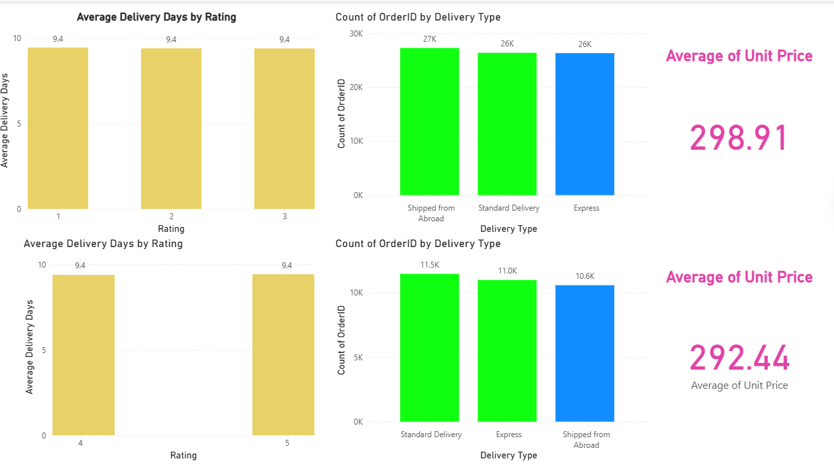

1. Using the time intelligence DAX function, create a table to compare each month’s sales with the previous year’s same month’s total sales. So there will be four columns in the output year, month, total sales, previous_years_sales.

Ans. 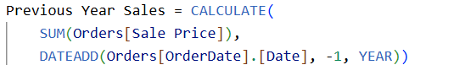

**Approach**: Created Table where Month-wise previous year's same period sale is plotted in the table.

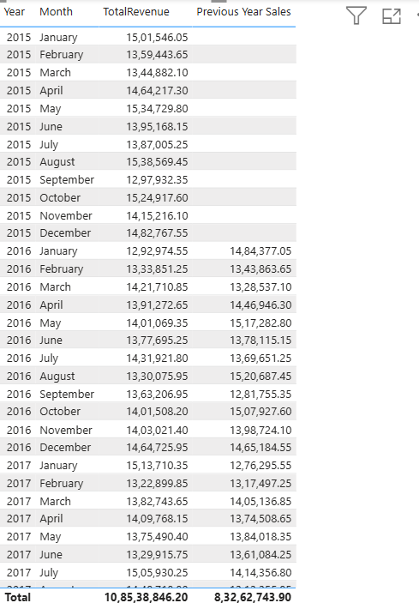

**15**. What do you understand by PowerBI gateway? What are its use cases?

Ans. Power BI Gateway is a tool that helps connect your local (on-premises) data sources, like SQL Server or Excel files saved on your computer or company server, to Power BI in the cloud. It acts as a bridge that allows Power BI to access and refresh data from these sources safely and automatically.

**Use Cases:**

1. **Scheduled Data Refresh:**
   * Automatically updates your Power BI dashboards using the latest data from local databases at set times.
2. **Live Data Access:**
   * Allows real-time connection to on-premises data so reports show current information instantly.
3. **Hybrid Data Models:**
   * Lets you combine both cloud-based and local data in one Power BI model for better analysis.
4. **Secure Data Transfer:**
   * Makes sure that data is encrypted and securely sent between local servers and the Power BI cloud.
5. **Collaboration:**
   * Helps multiple users view updated reports and dashboards without manually refreshing data.
6. **File Access:**
   * Connects Excel, CSV, and other files saved on local drives to Power BI for reporting and analysis.

**Benefits:**

1. **Automation:**
   * Keeps reports and dashboards updated without needing to manually upload new data.
2. **Security:**
   * Ensures sensitive data stays within the organization's network while still being accessible in Power BI.
3. **Versatility:**
   * Supports a wide range of data sources (databases, files, etc.), making it useful for different business needs.

1. How would you approach this problem, if the objective and subjective questions weren't given?

Ans. If the objective and subjective questions were not provided, I would have approached the problem with the following steps:

**Sales Performance:**

1. **Breakdown of Total Sales:**
   * Examine total sales across different years, zones, product categories, and subcategories.
2. **Product Performance:**
   * Identify high-performing products and those with low sales volume.

**Customer Behavior:**

1. **Order Patterns:**
   * Analyze order frequency, average order value, and commonly purchased categories/subcategories.
2. **Customer Segmentation:**
   * Group customers based on region, purchase volume, and product ratings to uncover trends.

**Delivery Efficiency:**

1. **Delivery Time Analysis:**
   * Calculate average delivery duration across delivery types and geographical zones.
2. **Delay Insights:**
   * Detect delivery delays by comparing delivery days with order status and assess their effect on customer satisfaction using ratings.

**Revenue Analysis:**

1. **Detailed Revenue Insights:**
   * Break down revenue sources including unit price, shipping fees, and final sales value.
2. **Profitability by Category:**
   * Evaluate profitability by comparing sales and unit prices across different product segments.

**Order Status and Cancellations:**

1. **Completion vs. Cancellation Rates:**
   * Track completed, canceled, and returned orders to understand order fulfillment.
2. **Root Causes:**
   * Analyze reasons behind cancellations and returns by category and subcategory.

**Seasonal Trends and Patterns:**

1. **Monthly/Yearly Variations:**
   * Review how sales, ratings, and delivery durations shift over time.
2. **Peak Demand Periods:**
   * Identify high-demand timeframes and study their impact on delivery performance and customer experience.

**Report:**

The stakeholders have asked for three tabs in the Reporting:

* Main Tab
* Product Tab
* Individual product Tab
* Using the Main tab in the Report, Stakeholders should be able to look at the total sales, revenue produced till now, and customer satisfaction for all product categories. This tab should have a slicer of product category and date.
* Using the product Tab, the management at the company should be able to look at the individual product category-wise performance like customer satisfaction, the number of customers purchasing that product, and which product requires improvement. This tab should have a slicer of gender, delivery type, product category, and age group
* Using the Individual product Tab, the Management and Stakeholder in the company want to look at the best product profile which would involve their total purchase, ID of that product, category/subcategory of that product, average rating, and how much revenue was generated by this product. All the metrics using which they can address the product very carefully in their orders.

**Make sure that all the visualizations look decent and are placed in a proper order. Each tab has different POCs (Point Of Contact), so make sure you involve all the metrics that POC may look at in that tab along with those mentioned in the tab description.**